**Table of Contents**

CHAPTER-1

1. **introduction…………………………………………………………..02**
   1. **BACKEND: MYSQL………………………………….…03**
   2. **MIDDLEWARE: PHP USING XAMPP…………….…04**

**1.3 FRONTEND: HTML, JAVASCRIPT, CSS…………... 06**

CHAPTER-2

**2.REQUIRAEMENT SPECIFICATION…………………………………….09**

**2.1 SOFTWARE SPECIFICATION………………………...09**

**2.3 HARDWARE SPECIFICATION……………………..…09**

CHAPTER-3

**3. Design………………………………………………………………………10**

**3.1 ER-diagRAM……………………………………...10**

**3.2 Schema and functional dependen…....11**

CHAPTER-4

**4. implementation………………………………………………….…….12**

CHAPTER-5

**5.SNAPSHOTS……………………………………………………….…………17**

CHAPTER-6

**6. CONCLUSION……………………………………………….……………….33**

CHAPTER-7

**7. BiBIliography …………………………………………………………..35**

**CHAPTER-01**

**INTRODUCTION**

**Background**

Shopping marts are characteristic of large floorage, extensive range of product categories, a variety of specialty stores as well as recreational offerings. After enjoying prosperity for quite a long time, shopping marts began to face serious challenges and bottlenecks in the late 1990s, when sales per square foot of mall space kept dropping.

Today, more and more mart managers localize vexation about how difficult it is to boost patronage and profitability. According to retail researchers, including Coalman (2002), Ibraham and Ng (2003) and Biba, Des Rosiers, Therauly and Villeneuve (2006), massive overdevelopment leads to mutual cannibalization among shopping malls. Consequently, their performances may weaken. Moreover, the rise of big boxes and discounters as well as other types of purchase outlets, which gradually popularize as alternate venues for shopping, probably poses one of the immediate threats to lure away traditional shoppers. Some mall management scholars such as Wakefield and Baker (1998), Wilhelm and Mottner (2005), Biba et al. (2006) and Backstrom (2006), in view of the tightening business environment in which shopping malls operate, theorize that the creation of entertainment experience may play an essential role in enhancing the shopping mall’s competitive edge. As entertainment paradigm researchers contend, successful management of a shopping mall involves the management of the entertainment experience.

**1.1 BACKEND: MYSQL**

**MYSQL** is very fast, easy to use RDBMS being used for many small and big businesses. It is becoming so popular because of many reasons those are that it is released under an open source license. So, you can have nothing to pay to use it. It is very powerful program in its own way.

**Objectives**

The main objectives of this project work are that:

Employee will be no longer adding for product details manually.

The admin can see and access the employee’s data.

This also will reduce the manual work of the persons in admin penal.

It helps the admin to know the number of employee that are there with their post.

Help the admin to disseminate information of employee without calling for a meeting or moving in supermarket.

To know the item available in stock

To ensure that the stock is well maintained.

**The system helps the admin to**:

Add and delete the employees with their post

Add and delete the suppliers for the stock in supermarket

View the feedback

View employee details

View suppliers details

View the billing records.

**1.2 MIDDLEWARE: PHP**

**PHP** is a server-side scripting language designed primarily for web development but also used as a general-purpose programming language. Originally created by Rasmus Lerdorf in 1994,the PHP reference implementation is now produced by The PHP Development Team. PHP originally stood for Personal Home Page, but it now stands for the recursive acronym PHP: Hypertext Preprocessor.

PHP code may be embedded into HTML or HTML5 markup, or it can be used in combination with various web template systems, web content management systems and web frameworks. PHP code is usually processed by a PHP interpreter implemented as a module in the web server or as a Common Gateway Interface (CGI) executable. The web server software combines the results of the interpreted and executed PHP code, which may be any type of data, including images, with the generated web page. PHP code may also be executed with a command-line interface (CLI) and can be used to implement standalone graphical applications

In this project the PHP contents is connected by Apache server to MYSQL. The connection is provided by XAMPP software.

**XAMPP** is a free and open source cross-platform web server solution stack package developed by Apache Friends, consisting mainly of the Apache HTTP Server, database, and interpreters for scripts written in the PHP and Perl programming languages. XAMPP stands for Cross-Platform (X), Apache (A), MariaDB (M), PHP (P) and Perl (P). It is a simple, lightweight Apache distribution that makes it extremely easy for developers to create a local web server for testing and deployment purposes. Everything needed to set up a web server – server application (Apache), database (MariaDB), and scripting language (PHP) – is included in an extractable file. XAMPP is also cross-platform, which means it works equally well on Linux, Mac and Windows. Since most actual web server deployments use the same components as XAMPP, it makes transitioning from a local test server to a live server extremely easy as well.

**Working with XAMPP:**

If you often want to access only a subset of your data that can be well defined by a filter condition, you can define a query. This is basically a name for the new view at the filtered data. You open the query and see the current data in the table layout that you defined.

As we are using xampp, so the queries are done in the web pages like list some stored contents or insert or delete.

The xampp comes with Apache server, we need to start the server by clicking on the “start” button, and for the Sql click on “start” button , as the both are in running state now you can use the web page to add/view/delete data ,

**Creating a Database and Inserting Data**

the next step is running MySQL and creating a database and table which will hold the information to be used by our website. In order to start click on “admin” action on the MySQL present in Xampp Control Panel, this will take user to phpMyAdmin page, or type http://localhost/phpMyAdmin/ into our web browser. If successful, we will be presented with a phpMyAdmin start page similar to the one shown below.

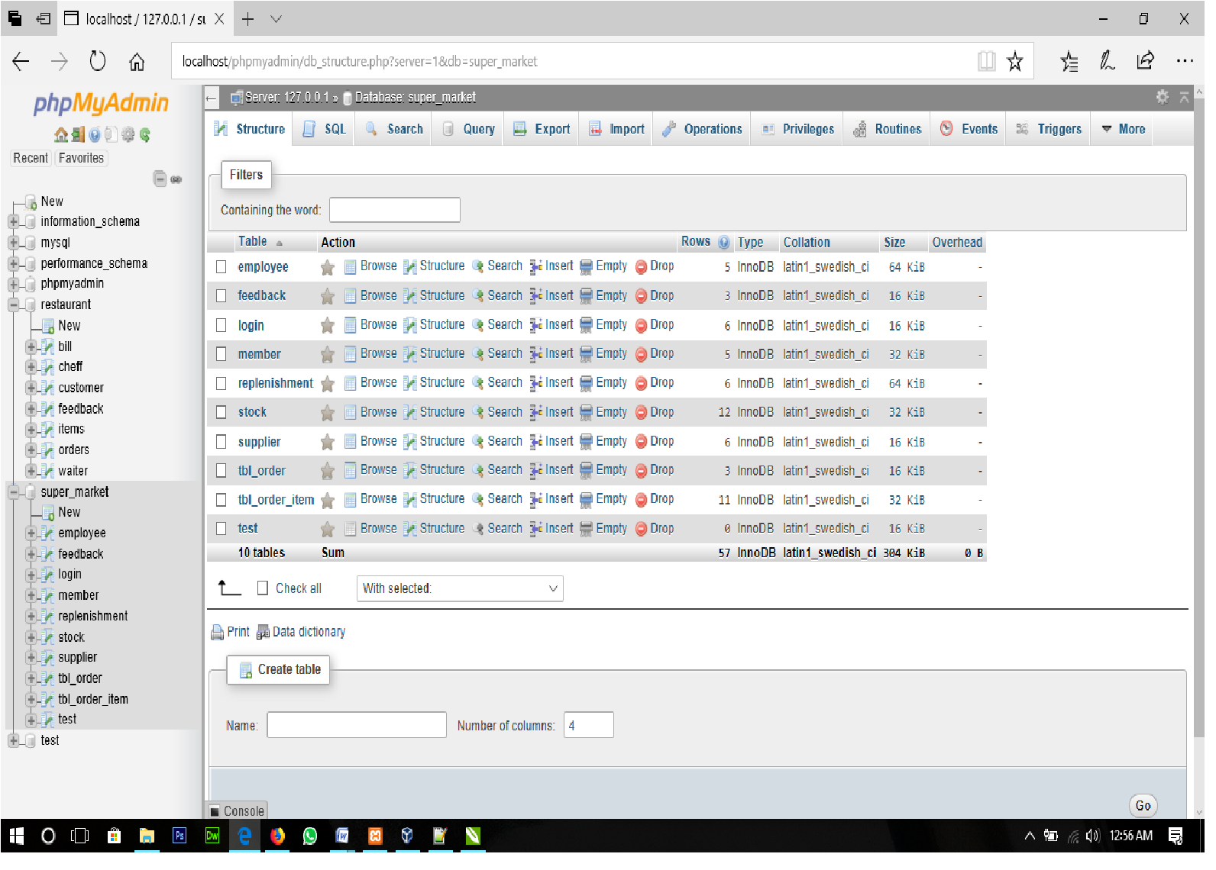

Fig 1.2.1

Here the creation of database, table and their relationship can be done by clicking on SQL and entering the instruction to MySQL or the easy way is :-

* Click on “new”
* Give the name for database .
* Select the collation and
* Click on create

**Creating new tables**

* give table name in present database
* enter the numbers of columns
* click on “go”
* now give names, type, length, values, attributes, key value etc for the fields
* click on save to create.

**Viewing Database**

* Click on the database name present on the left side .

**Viewing tables**

* Click on database
* Click on the table to view

To use web page you need to give the php files in “C:\xampp\htdocs” and open web browser and use URL= https://localhost/page_name.php

Note: make sure the Xampp (Apache and Sql) are in running state.

* 1. **FRONTEND**
* **Hypertext Markup Language** (**HTML**) is the standard markup language for creating web pages and web applications. Web browsers receive HTML documents from a web server or from local storage and render them into multimedia web pages.
* **CSS: Cascading Style Sheets** (**CSS**) is a style sheet language used for describing the presentation of a document written in a markup language.
* **JAVASCRIPT: JavaScript** often abbreviated as **JS**, is a high-level, dynamic, weakly typed, prototype-based, multi-paradigm, and interpreted programming language. Alongside HTML and CSS, JavaScript is one of the three core technologies of World Wide Web content production.

**Advantages of the database:**

I have designed the given proposed system in the PHP to automate the process of Supermarket. This project is useful for the authorities who keep track of all the users registered. The authority can add employee, supplier details, product details, view billing etc.

The following steps that give the detailed information of the need of proposed system are:

Performance:

During past several decades, the records are supposed to be manually handled for all activities. The manual handling of the record is time consuming and highly prone to error. To improve the performance of the Supermarket System, the computerized system is to be undertaken. This project is fully computerized and user friendly even that any of the members can see the report and status of the company.

Efficiency:

The basic need of this website is efficiency. The website should be efficient so that whenever a new user submits his/her details the website is updated automatically .This record will be useful for other users instantly.

Control:

The complete control of the project is under the hands of authorized person who has the password to access this project and illegal access is not supposed to deal with. All the control is under the administrator and the other members have the rights to just seethe records not to change any transaction or entry.

Security:

Security is the main criteria for the proposed system. Since illegal access may corrupt the database. So security has to be given in this project.

**Advantages of xampp:**

* It is Easy to Install as compare to other web server's like WAMP.
* It is Multi Cross Platform which means XAMPP is available for Windows and Linux.
* It also comes with a number of other modules including OpenSSL, phpMyAdmin, MediaWiki, Joomla, WordPress and more.
* XAMPP is offered in both a full and a standard version (Smaller version).
* You can start and stop the whole webserver+database stack with one command.

**Disadvantages of xampp:**

* Configuration and Setting is tough to do as compare to other server(WAMP, LAMP)

**CHAPTER-2**

**REQUIREMENT SPECIFICATION**

**2.1 Software requirements:**

**Operating System:**

* Xubuntu
* Windows

**Operating System Type:**

* 64-bit

**Software used:**

* Notepad++ v-7.5.1
* Xampp Control Panel v3.2.2

**2.2Hardware requirements:**

Processor:

Intel® Pentium(R) CPU N3710 @ 1.60GHz * 4 or Higher

Graphics:

Intel® HD Graphics 405(Braswell) or Higher

Disk: 20GB or Higher

RAM: 1GB or Higher

Network Connectivity.

**CHAPTER-3**

**DESIGN**

* 1. **ER-DIAGRAM**

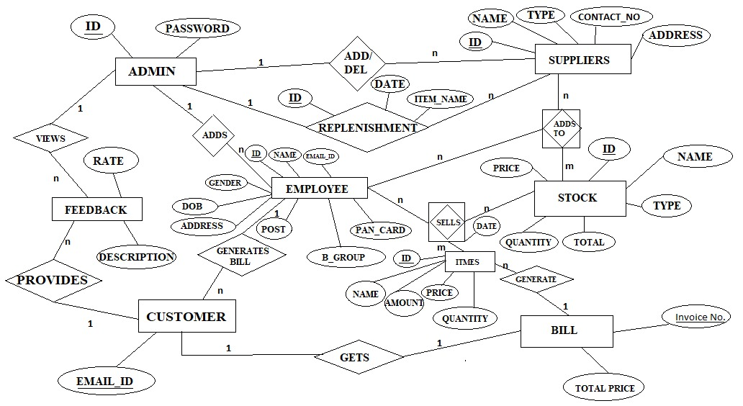

**3.2 SCHEMADIAGAM**

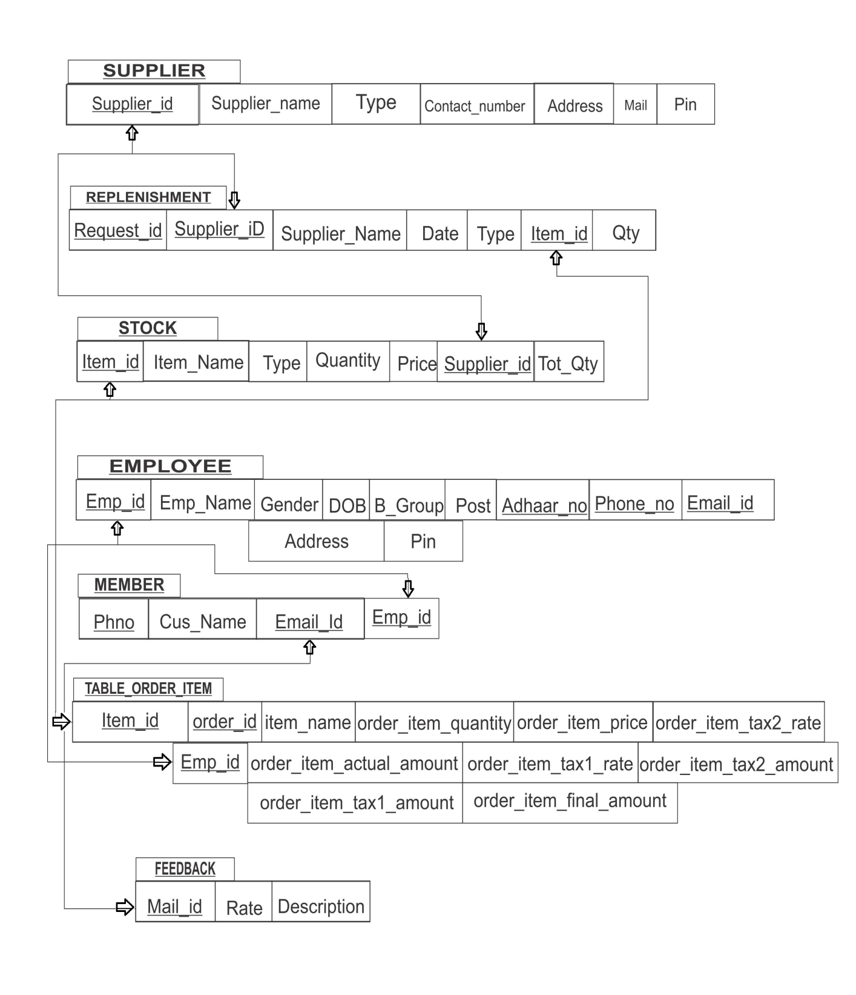

**CHAPTER-04**

**IMPLEMENTATION**

This chapter is to show the database creation and insertion of values for every particular table

**4.1 Database**

**.TO CREATE EMPLOYEE TABLE**

CREATE TABLE `employee` (

`Emp_Id` varchar(10) NOT NULL,

`Emp_Name` varchar(30) NOT NULL,

`Gender` varchar(6) NOT NULL,

`DOB` date NOT NULL,

`B_Group` varchar(3) NOT NULL,

`Post` varchar(15) NOT NULL,

`Adhaar_no` varchar(12) NOT NULL,

`Phone_no` bigint(10) NOT NULL,

`Email_Id` varchar(30) NOT NULL,

`Address` varchar(50) NOT NULL,

`Pin` int(11) DEFAULT NULL);

**.INSERTING EMPLOYEE VALUES**

INSERT INTO `employee` (`Emp_Id`, `Emp_Name`, `Gender`, `DOB`, `B_Group`, `Post`, `Adhaar_no`, `Phone_no`, `Email_Id`, `Address`, `Pin`) VALUES

('1', 'Payal', 'Female', '0000-00-00', 'B+', 'CLERK', '2147483647', 2147483647, 'paayalshah93@gmail.com', 'Kumarswamy Layout', 560078);

**.TO CREATE_FEEDBACK TABLE**

CREATE TABLE `feedback` (

`Mail_id` varchar(30) NOT NULL,

`Rate` int(1) NOT NULL,

`Description` text NOT NULL);

**.INSERTING FEEDBACK VALUES**

INSERT INTO `feedback` (`Mail_id`, `Rate`, `Description`) VALUES

('akii@gmail.com', 5, 'Awesome...');

**.TO CREATE LOGIN TABLE**

CREATE TABLE `login` (

`ID` varchar(20) NOT NULL,

`Password` varchar(20) NOT NULL);

**INSERTING LOGIN VALUES**

INSERT INTO `login` (`ID`, `Password`) VALUES

('1', 'praveen'), ('admin', 'admin');

**.TO CREATE MEMBER TABLE**

CREATE TABLE `member` (

`Phno` bigint(10) NOT NULL,

`Cus_Name` varchar(20) NOT NULL,

`Email_Id` varchar(30) NOT NULL);

**INSERTING MEMBER VALUES**

INSERT INTO `member` (`Phno`, `Cus_Name`, `Email_Id`) VALUES

(9090909090, 'Ajay', 'ajay@gmail.com');

**.TO CREATE REPLENISHMENT TABLE**

CREATE TABLE `replenishment` (

`Request_Id` int(100) NOT NULL,

`Supplier_ID` varchar(20) NOT NULL,

`Date` date NOT NULL,

`Type` varchar(20) NOT NULL,

`Item_id` int(5) NOT NULL,

`Qty` int(100) NOT NULL);

**INSERTING REPLENISHMENT VALUES**

INSERT INTO `replenishment` (`Request_Id`, `Supplier_ID`, `Date`, `Type`, `Item_id`, `Qty`) VALUES

(1, 's1', '2017-11-30', 'home_personal_care', 10, 10);

**.TO CRAETE STOCK TABLE**

CREATE TABLE `stock` (

`Item_id` int(5) NOT NULL,

`Item_Name` varchar(20) NOT NULL,

`Type` varchar(20) NOT NULL,

`Quantity` int(4) NOT NULL,

`Price` float NOT NULL,

`Supplier_Id` varchar(20) NOT NULL);

**INSERTING STOCK VALUES**

INSERT INTO `stock` (`Item_id`, `Item_Name`, `Type`, `Quantity`, `Price`, `Supplier_Id`) VALUES

(10, 'Fair & Lovely', 'home_personal_care', 20, 50, 's1');

**.TO CREATE SUPPLIER TABLE**

CREATE TABLE `supplier` (

`Supplier_Id` varchar(20) NOT NULL,

`Supplier_Name` varchar(30) NOT NULL,

`Type` varchar(20) NOT NULL,

`Contact_No` bigint(10) NOT NULL,

`Address` text NOT NULL,

`pin` int(11) DEFAULT NULL,

`Mail` varchar(25) DEFAULT NULL);

**INSERTING SUPPLIER VALUES**

INSERT INTO `supplier` (`Supplier_Id`, `Supplier_Name`, `Type`, `Contact_No`, `Address`, `pin`, `Mail`) VALUES

('s1', 'Adii', 'home personal care', 9898989898, 'K.S. Layout ', 560111, 'adiii@gmail.com');

**.TO CREATE TABLE ORDER TABLE**

CREATE TABLE `tbl_order` (

`order_id` int(11) NOT NULL,

`order_no` varchar(50) NOT NULL,

`order_date` date NOT NULL,

`order_receiver_name` varchar(250) NOT NULL,

`order_receiver_address` text NOT NULL,

`order_total_before_tax` decimal(10,2) NOT NULL,

`order_total_tax1` decimal(10,2) NOT NULL,

`order_total_tax2` decimal(10,2) NOT NULL,

`order_total_tax` decimal(10,2) NOT NULL,

`order_total_after_tax` decimal(10,2) NOT NULL,

`order_datetime` datetime NOT NULL);

**INSERTING TABLE ORDER VALUES**

INSERT INTO `tbl_order` (`order_id`, `order_no`, `order_date`, `order_receiver_name`, `order_receiver_address`, `order_total_before_tax`, `order_total_tax1`, `order_total_tax2`, `order_total_tax`, `order_total_after_tax`, `order_datetime`) VALUES

(15, '111', '2017-11-30', 'Sunny', 'K.S. Layout', '305.00', '2.00', '2.68', '4.68', '309.68', '2017-11-30 00:00:00');

**.TO CREATE TABLE ORDER ITEM TABLE**

CREATE TABLE `tbl_order_item` (

`order_item_id` int(11) NOT NULL,

`order_id` int(11) NOT NULL,

`item_name` varchar(250) NOT NULL,

`order_item_quantity` decimal(10,2) NOT NULL,

`order_item_price` decimal(10,2) NOT NULL,

`order_item_actual_amount` decimal(10,2) NOT NULL,

`order_item_tax1_rate` decimal(10,2) NOT NULL,

`order_item_tax1_amount` decimal(10,2) NOT NULL,

`order_item_tax2_rate` decimal(10,2) NOT NULL,

`order_item_tax2_amount` decimal(10,2) NOT NULL,

`order_item_final_amount` decimal(10,2) NOT NULL);

**INSERTING TABLE ORDER ITEM VALUES**

INSERT INTO `tbl_order_item` (`order_item_id`, `order_id`, `item_name`, `order_item_quantity`, `order_item_price`, `order_item_actual_amount`, `order_item_tax1_rate`, `order_item_tax1_amount`, `order_item_tax2_rate`, `order_item_tax2_amount`, `order_item_final_amount`) VALUES

(29, 15, 'Fair & Lovely', '2.00', '50.00', '100.00', '1.00', '1.00', '1.00', '1.00', '102.00');

**CHAPTER-05**

**SNAPSHOTS**

5.1 HOME PAGE

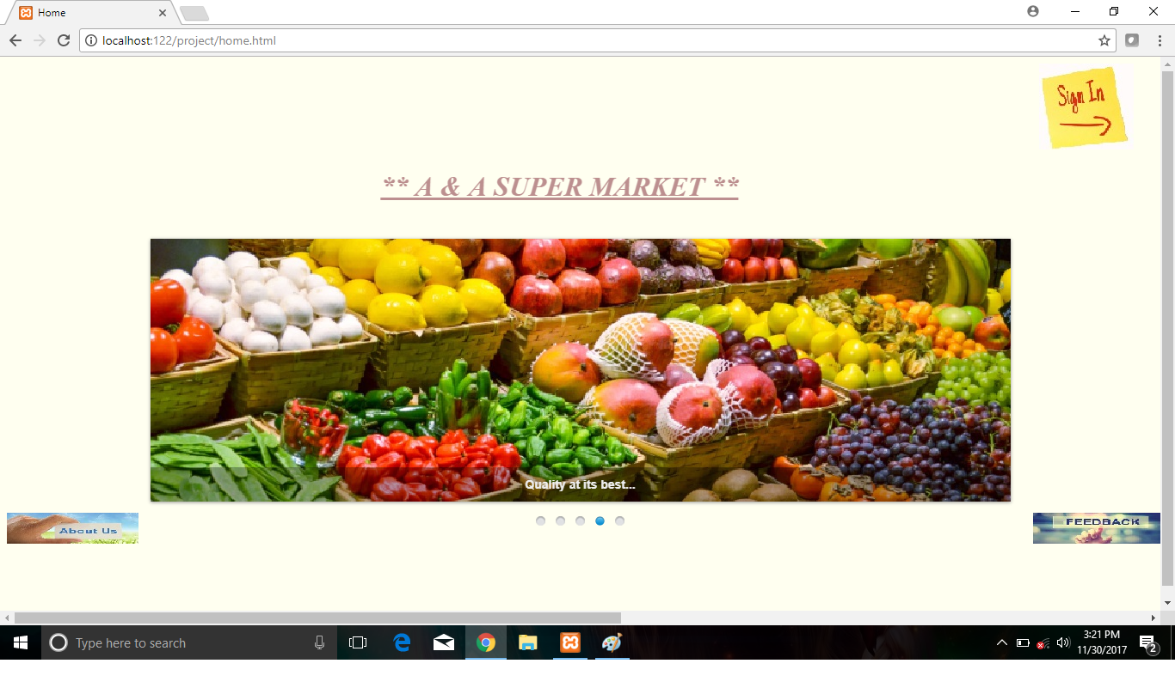5.2 LOGIN PAGE

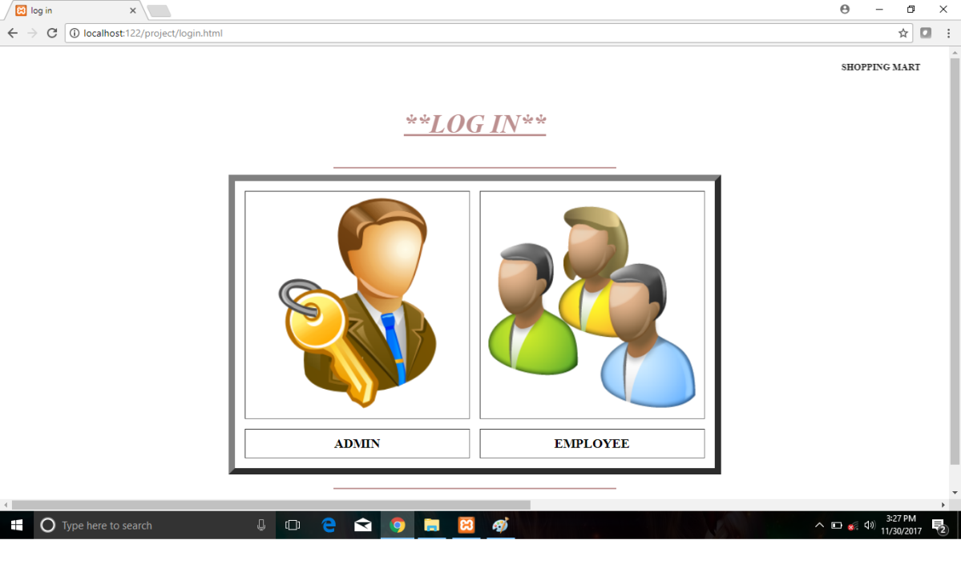

5.3 ADMIN LOGIN PAGE

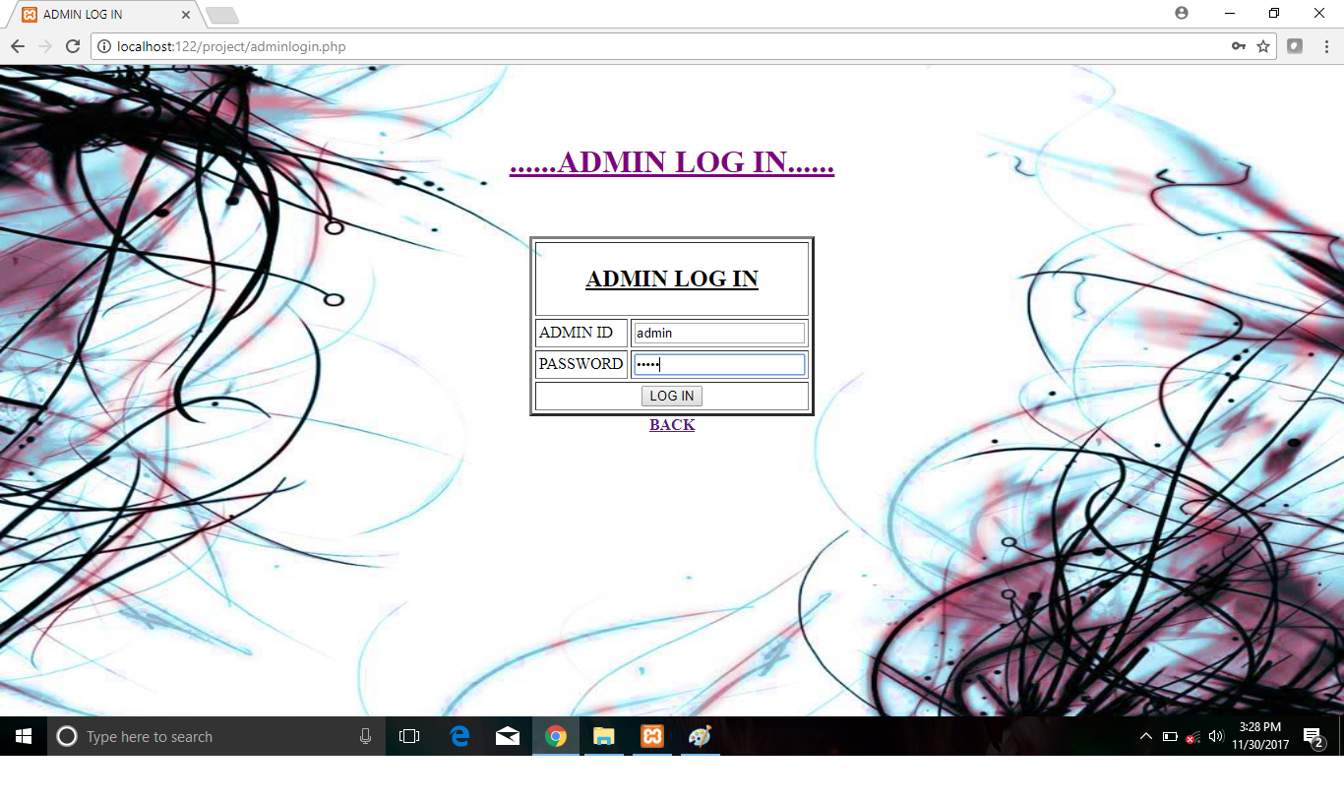

5.4 ADMIN HOME PAGE

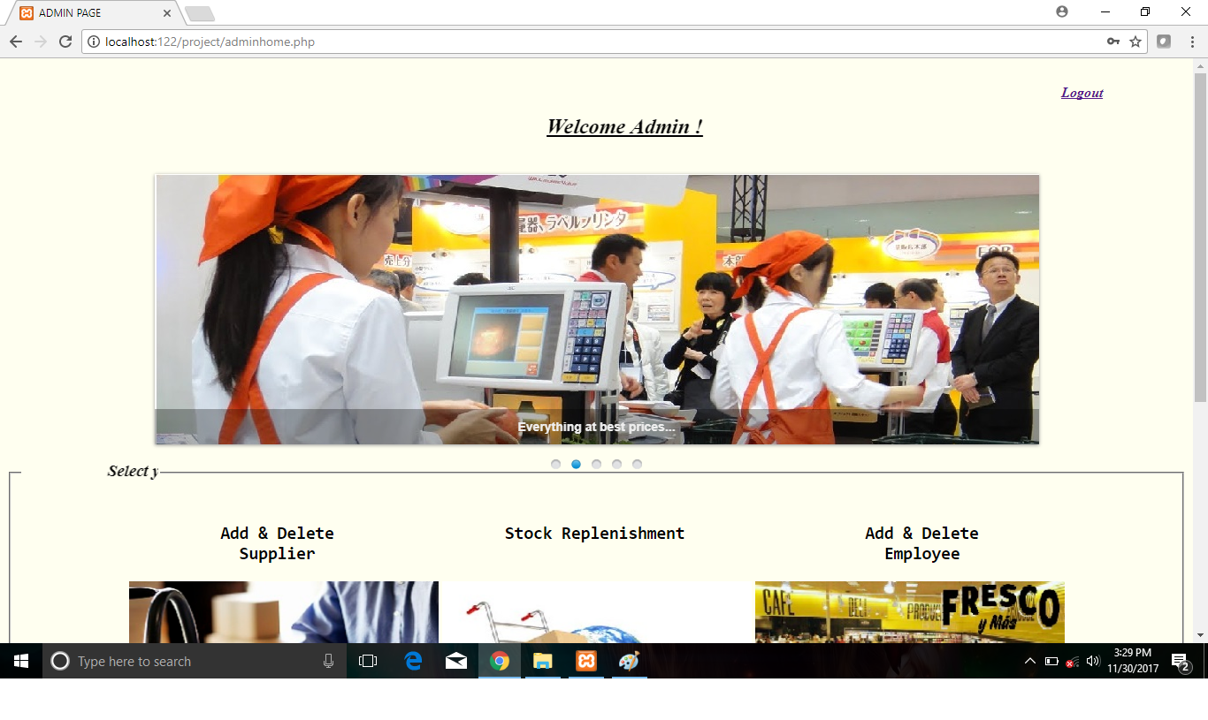

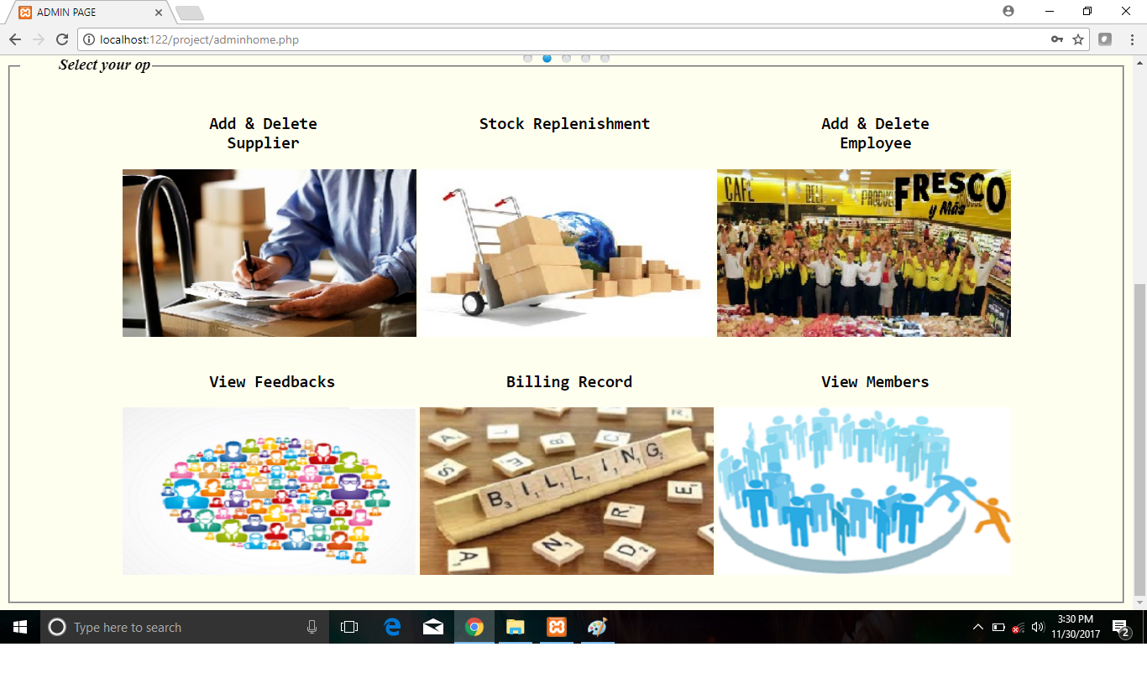

5.5 ADD OR DELETE SUPLIER 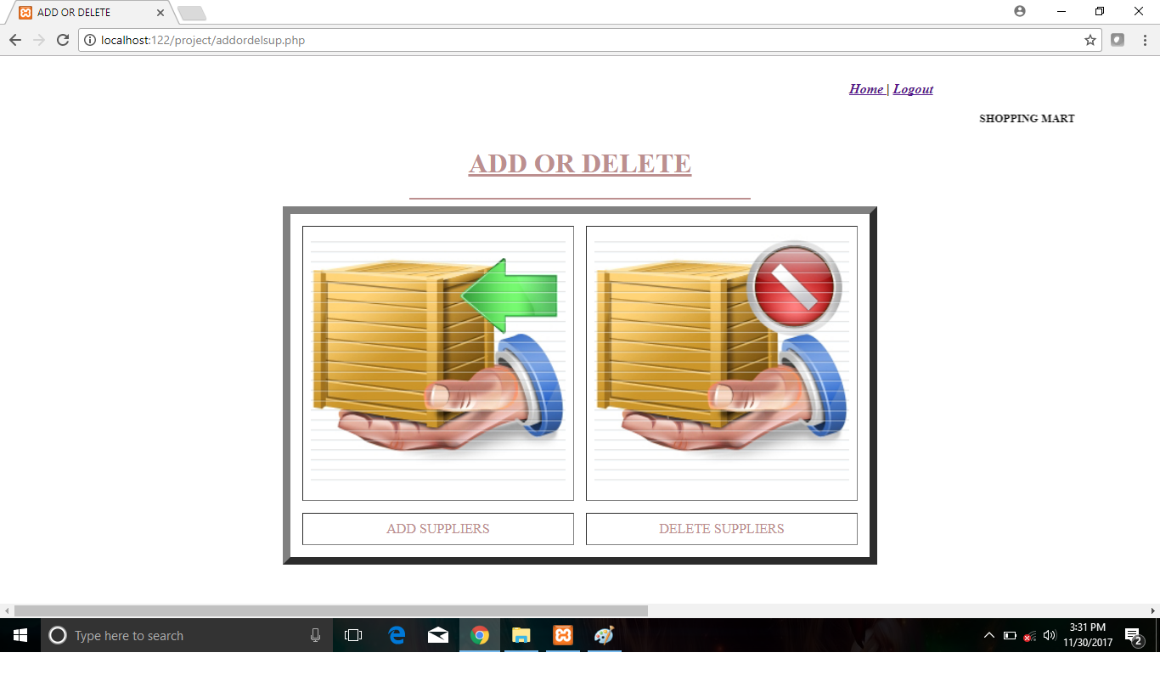

5.6 ADD SUPLIER

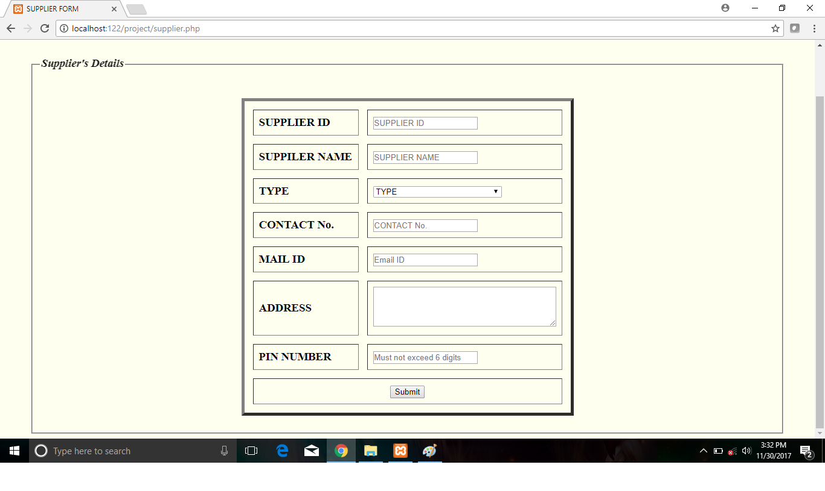

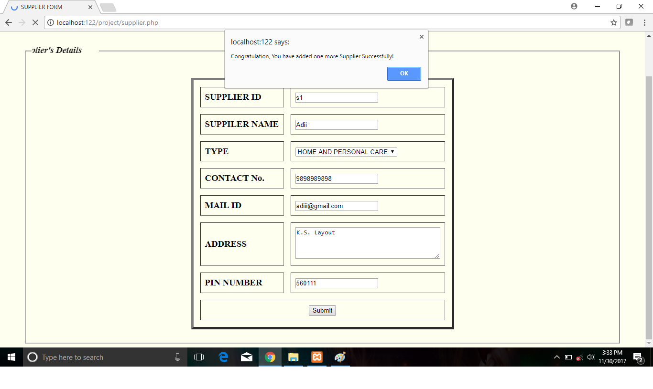

5.7 VIEW SUPILER

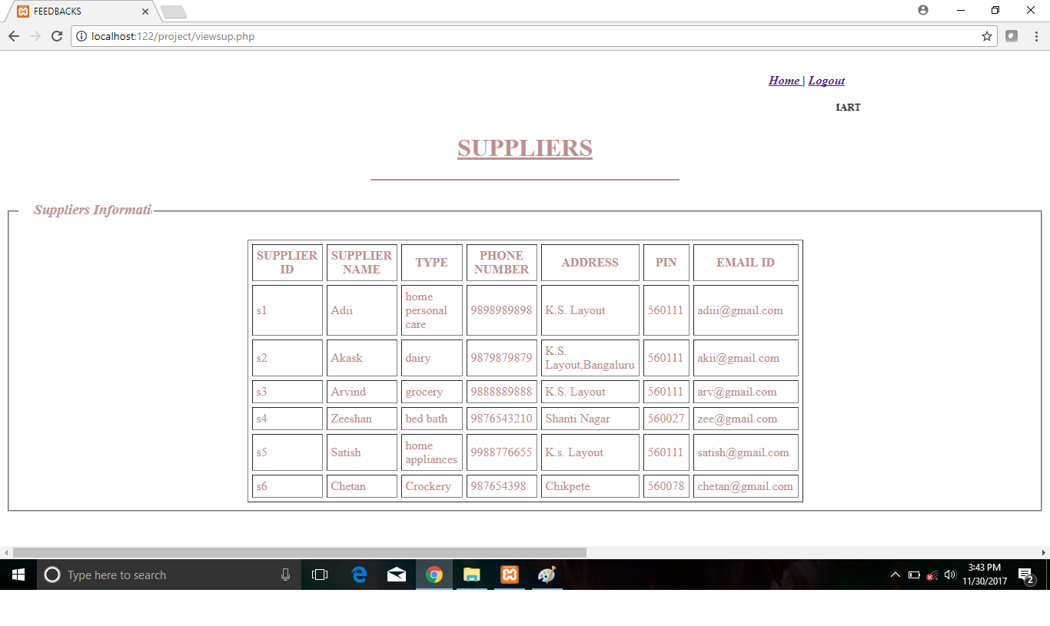

5.8 DELETE SUPILER

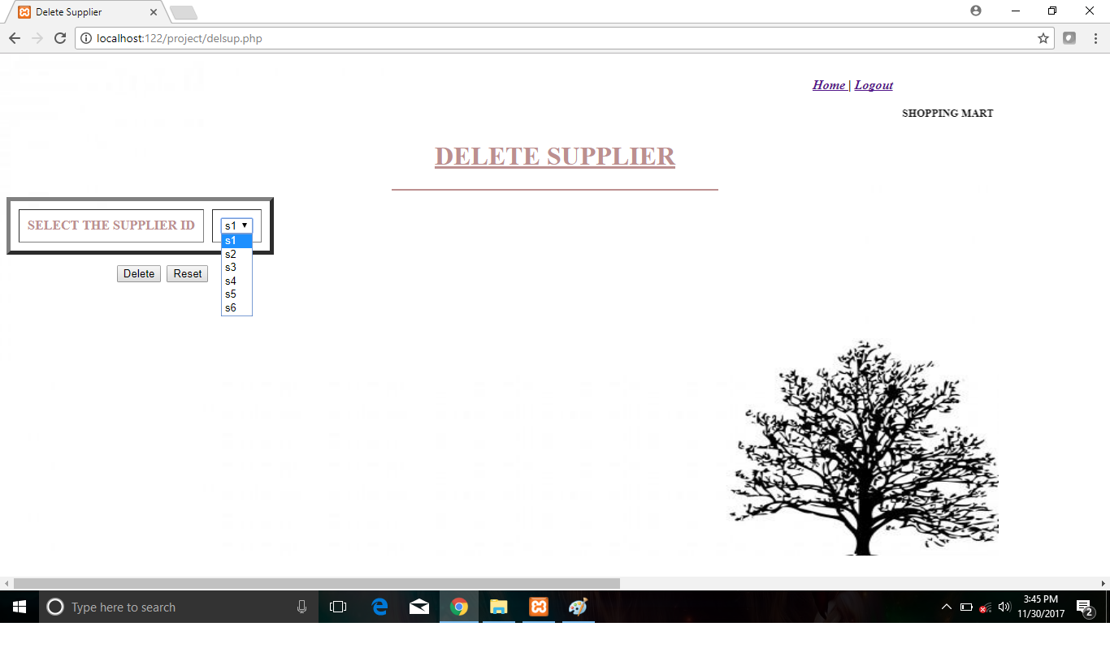

5.9 STOCK REPLENESHMENT

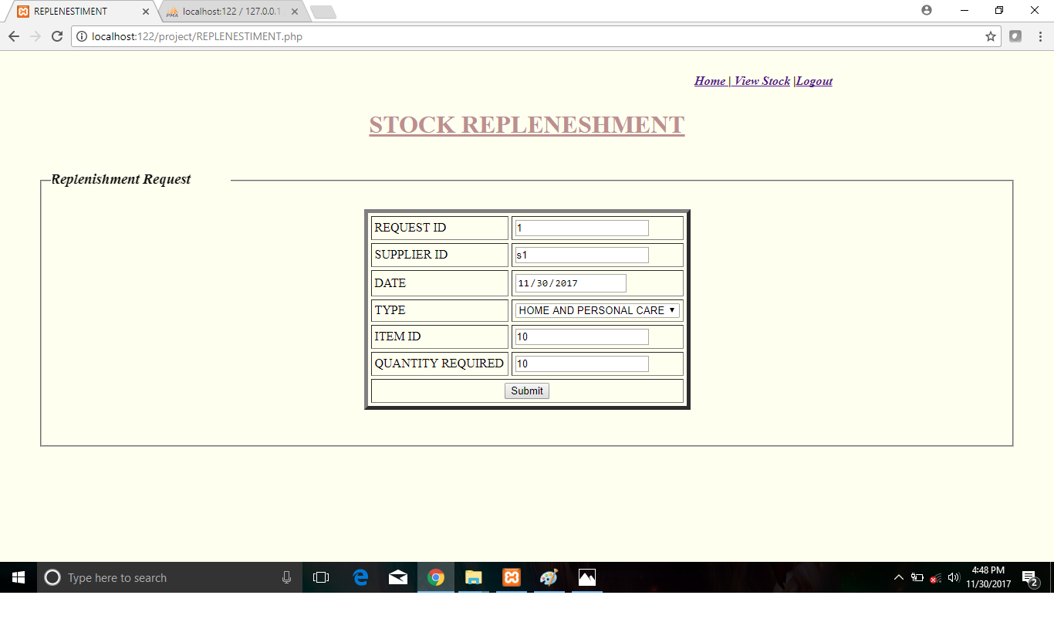

5.10 REPLENISHED ITEM

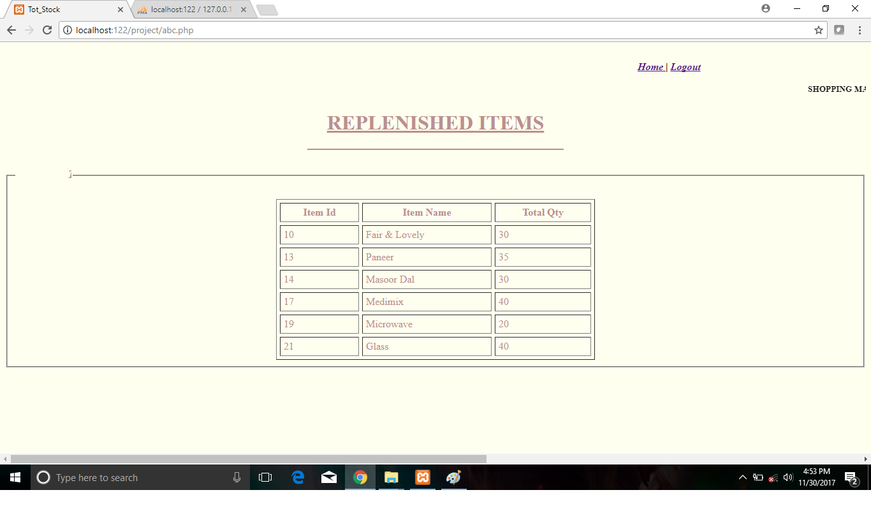

5.11 ADD/ DELETE EMPLOYEE

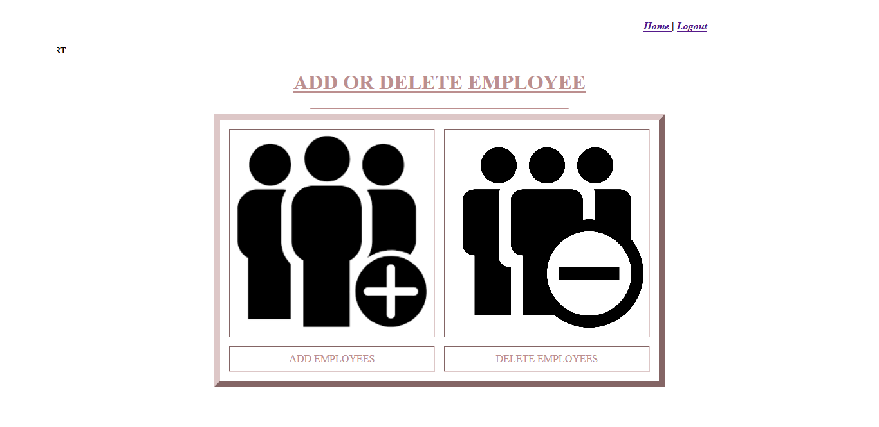

5.12 ADD EMPLOYEE

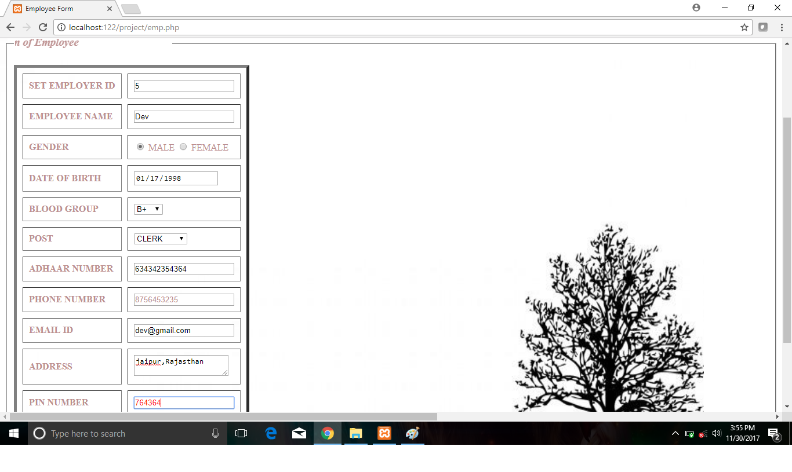

5.13 VIEW EMPLOYEE

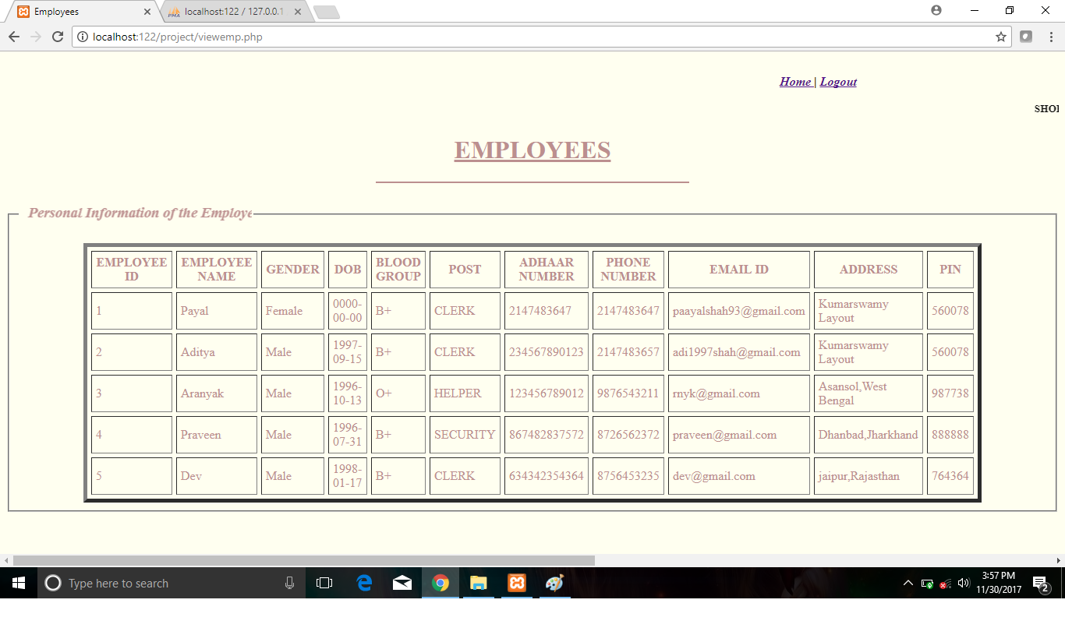

5.14DELETE EMPLOYEE

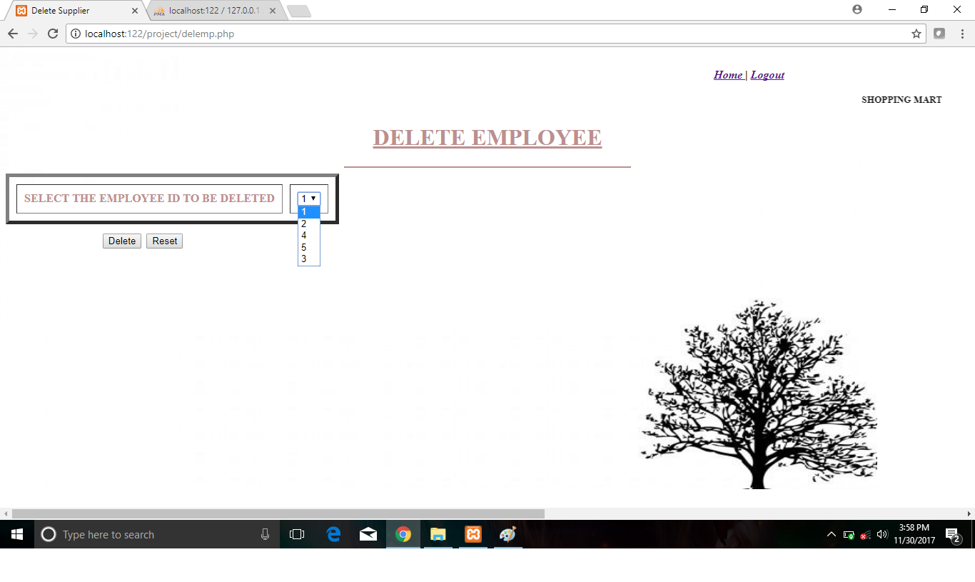

5.15 VIEW FEEDBACK

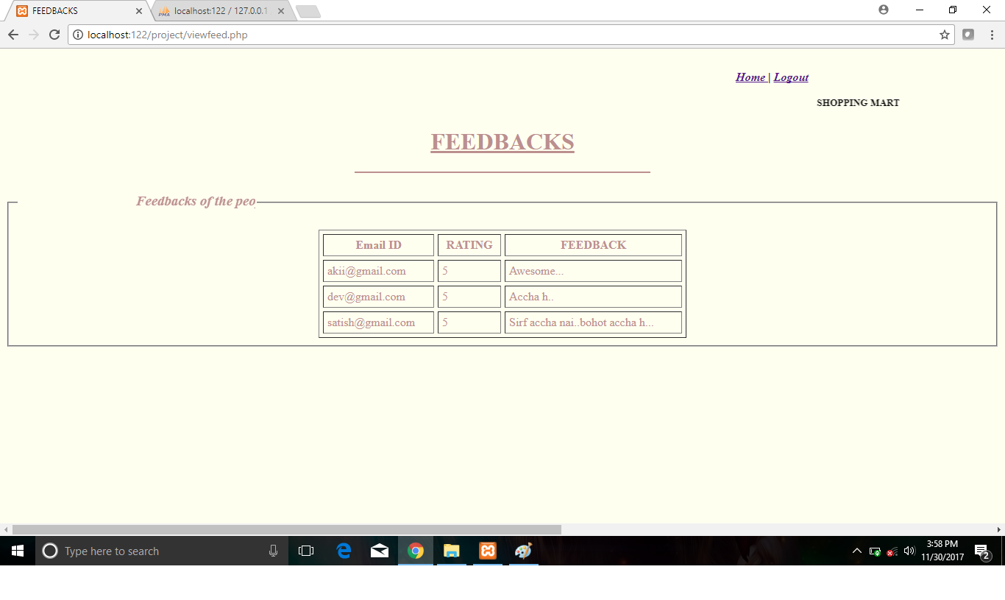

5.16 VIEW BILL RECORDS

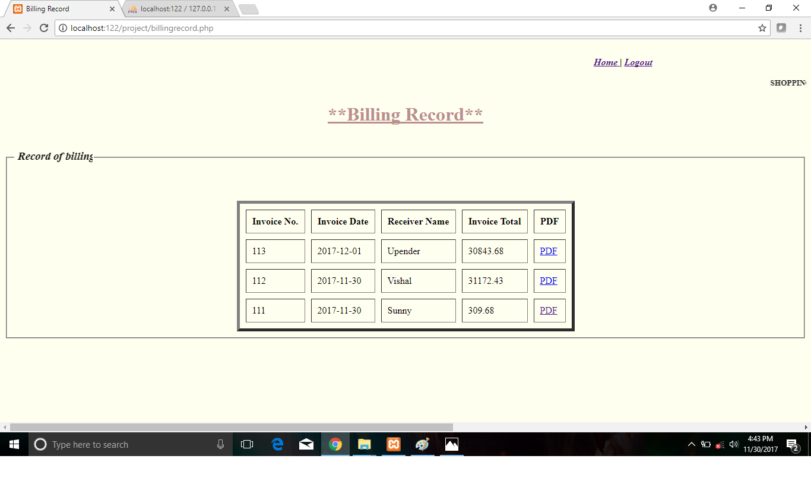

5.17 VIEW MEMBERS

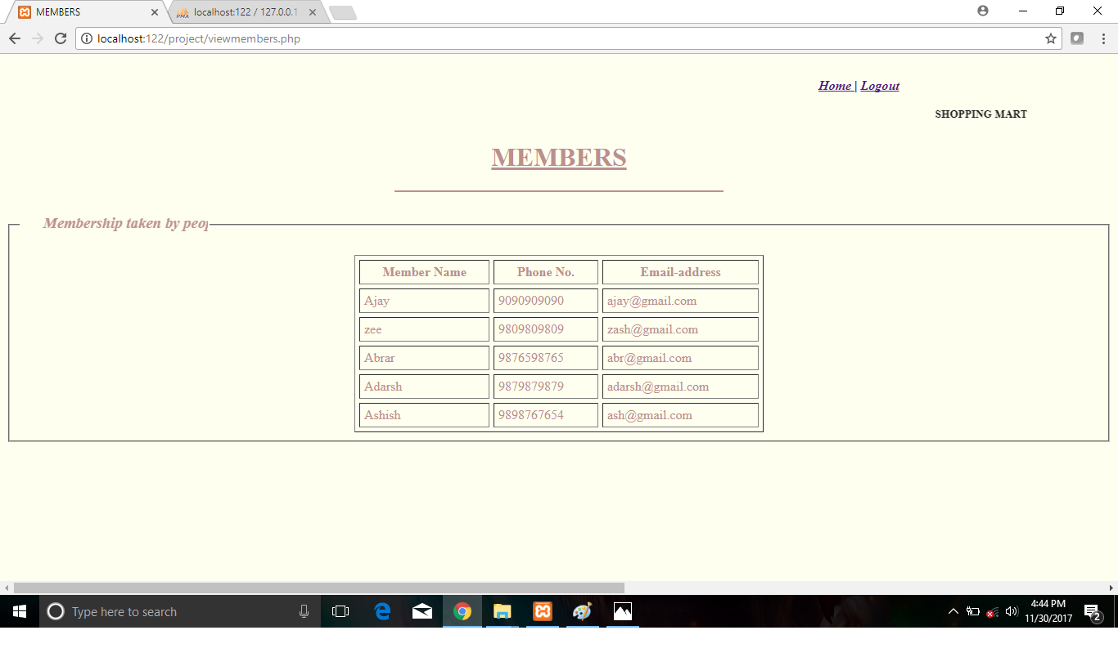

5.18 EMPLOYEE LOG-IN

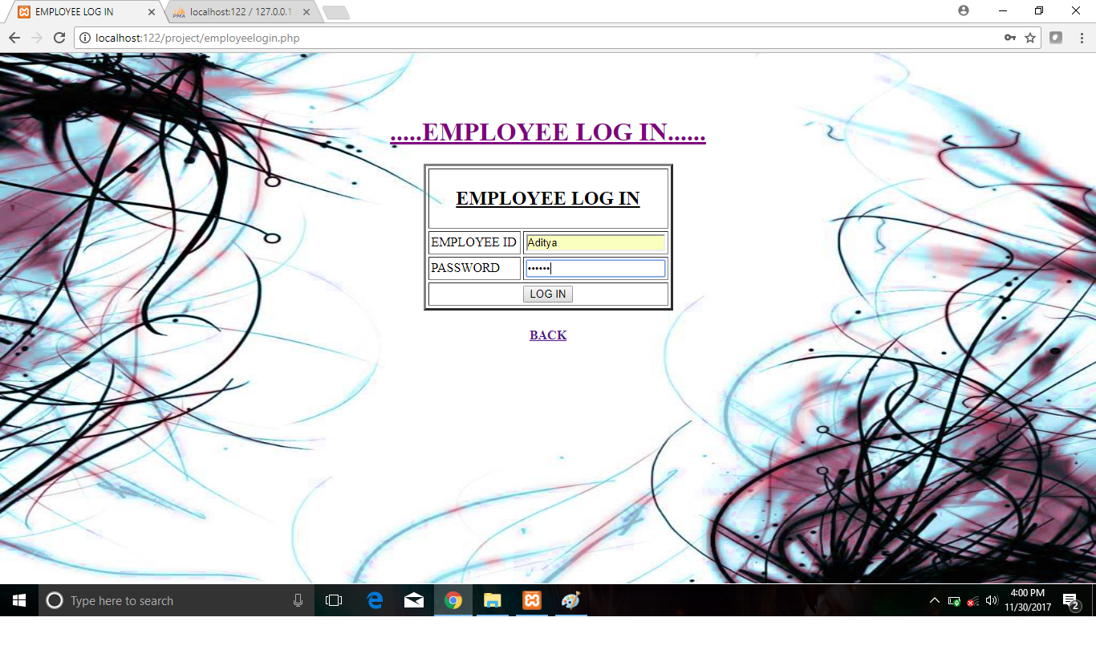

5.19 EMPLOYEE HOME PAGE

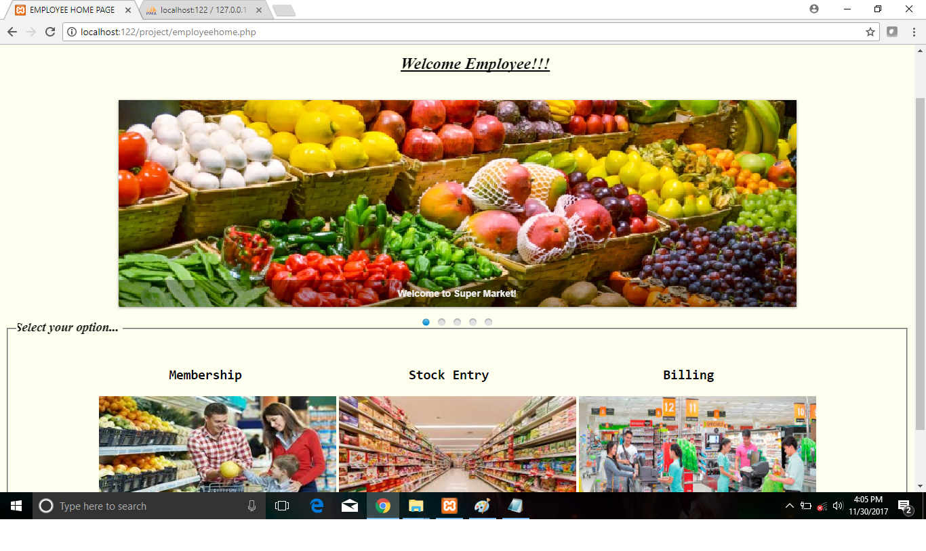

5.20 ADD MEMBERS

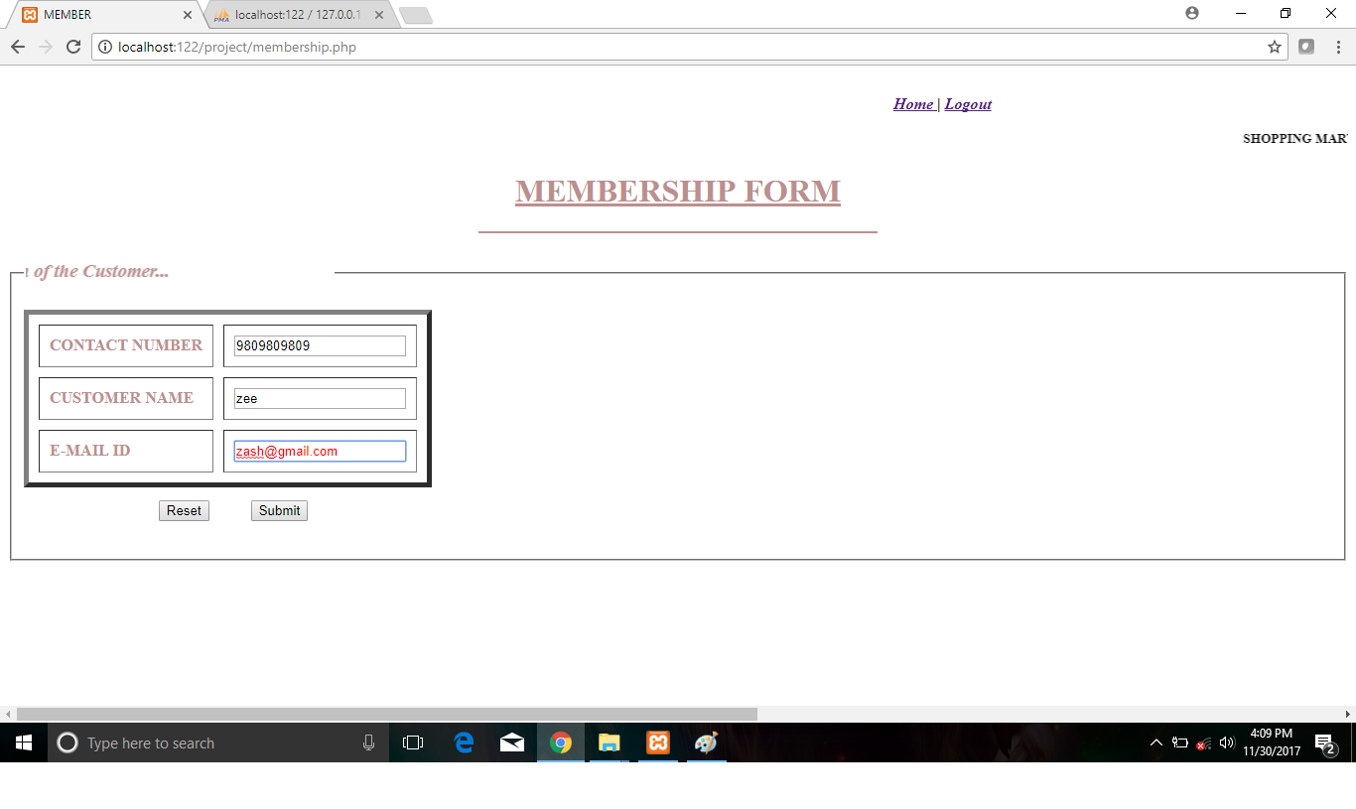

5.21 STOCK ENTRY

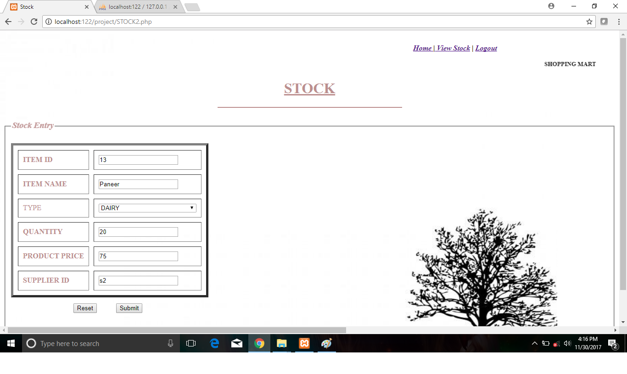

5.22 VIEW STOCK

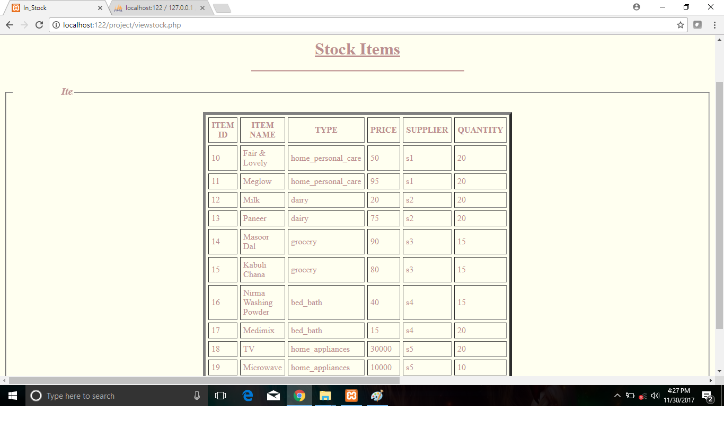

5.23 BILLING PAGE

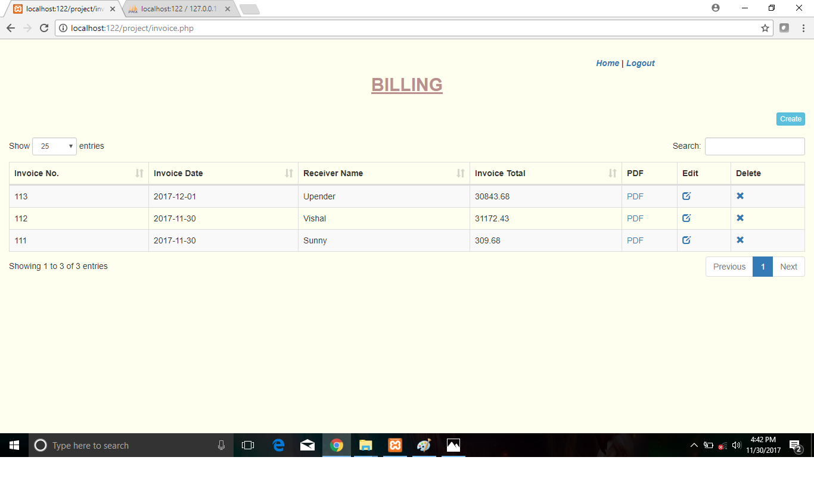

5.24 BILL CREATION

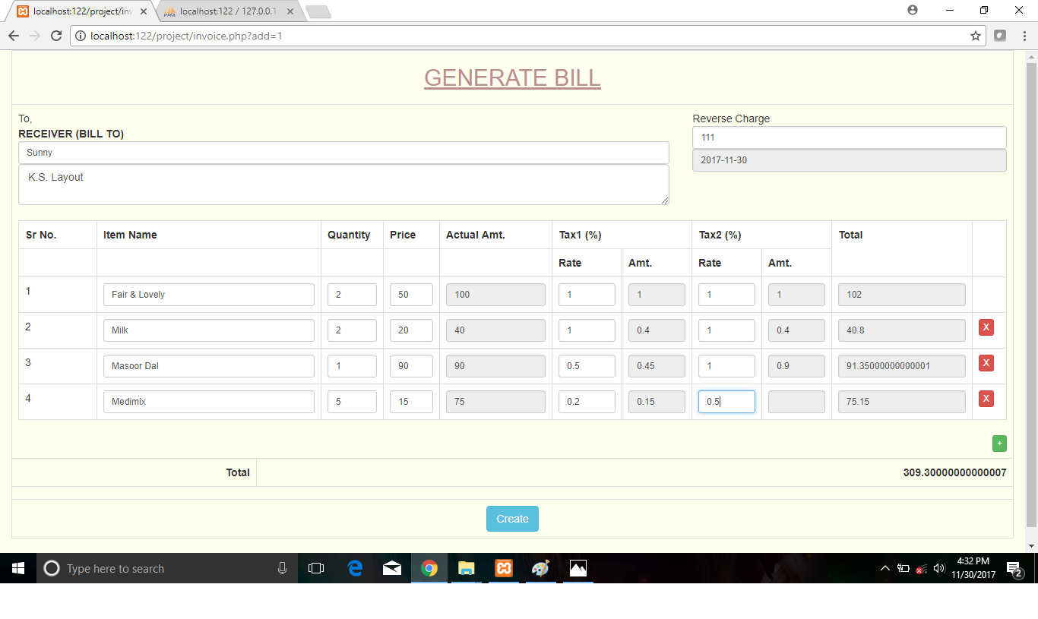

5.25 BILL

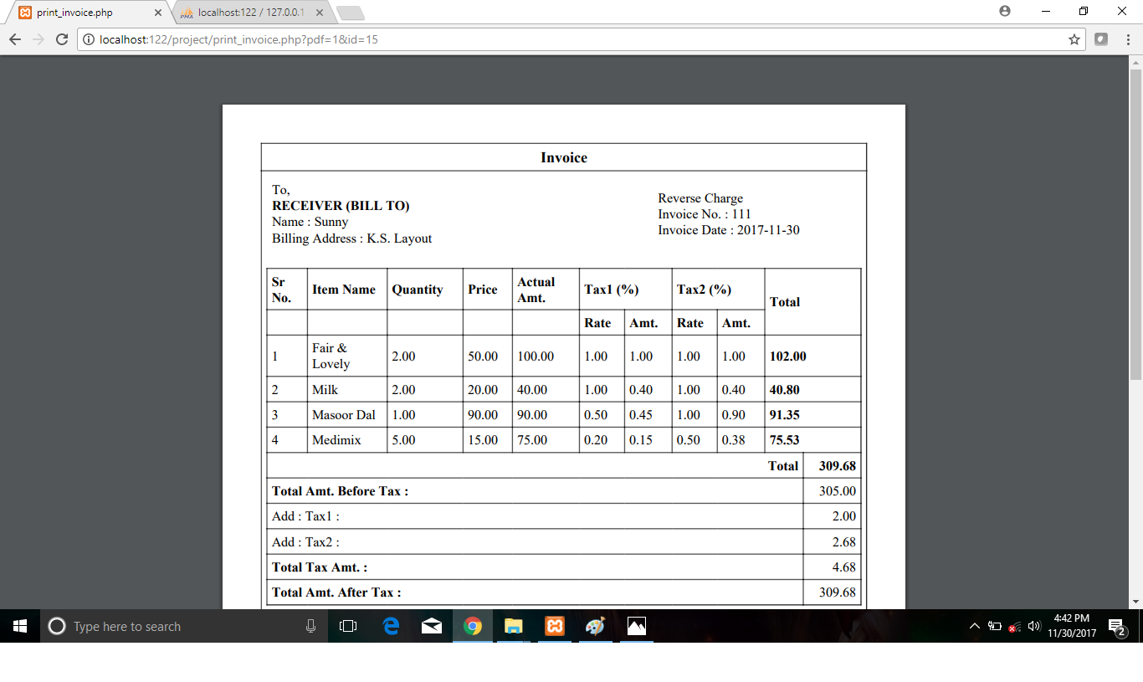

5.26 ABOUT US PAGE

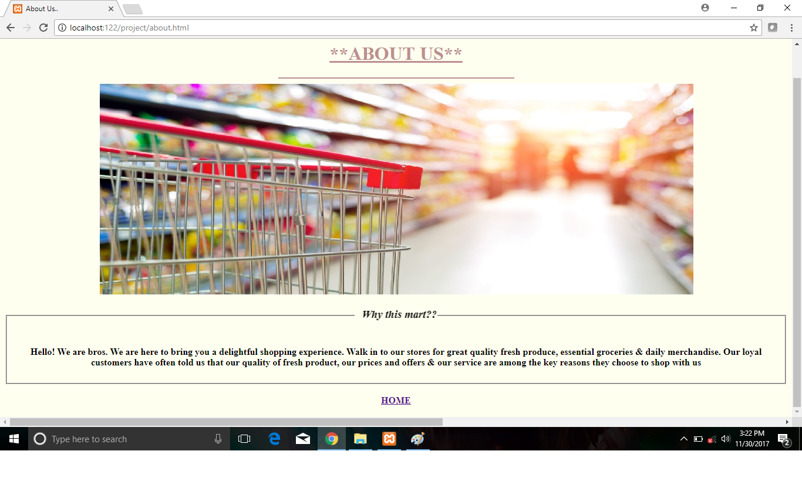

5.27 FEEDBACK PAGE

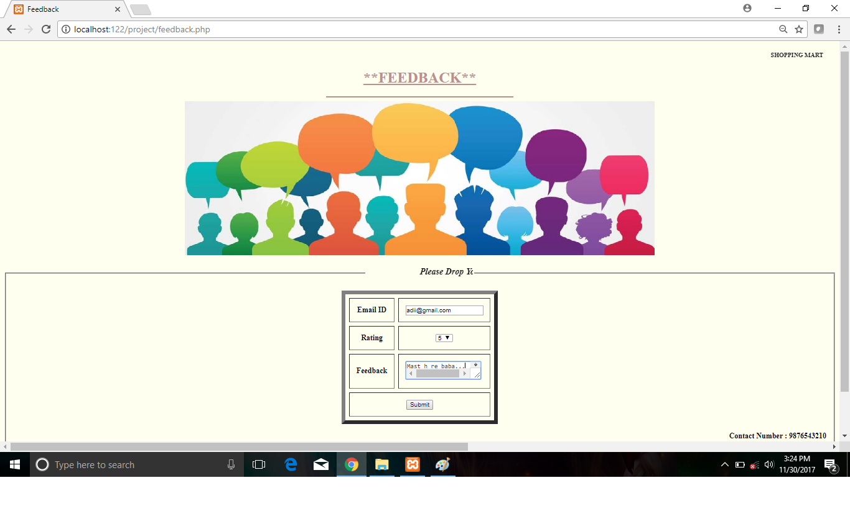

**CHAPTER-06**

**CONCLUSION AND FUTURE ENHANCEMENT**

**Conclusion:**

With the increase in the marketing industry, today Super marketing Management in India is not only restricted to maeket but has gone a long way.

India is being considered as one of the most popular travel destinations in the world. To conclude, this system is designed to be a useful replacement to the traditional manual record entry that has prevailed in most products. It provides the user with an intuitive user interface which makes it easy for him/her to go about his daily job without engaging in trivialities like maintaining a record book or updating the columns.

We envision this A&A Supermarket System to permanently replace the current tedious system, and we think that it is a step in the right direction. It will work in conjunction with day-to-day shop keeping responsibilities and is designed to be intuitive and easy to grasp, even for employees who are not familiar with using a computer, thus not hindering the other daily responsibilities of the employees.

This project achieves the important goal of centralizing all transactions, thus making it easy for the company to keep records, and thus calculate its profits/losses over time.

**Future Scope:**

The current level of empirical research done on retail in the Indian context is miniscule. This study is concentrated on perceptions and evaluations of food & grocery stores and seeks to build on the very little research done in retailing in general, and data mining in retailing in particular. In the future, researchers can seek other relevant research problems from the industry and from existing literature.

Being in this industry, one may be expected to work in the following departments, i.e. management, housekeeping, hospitality, front office operations, marketing and sales, accounts etc.

There are a large number of degree/diploma/certificate courses which many institutes offer. You can have a look at this link. It is very important to keep in mind the institute from where you are pursuing these courses and the placement opportunities they provide.

The Super market management Industry is not looking for scholars, but is looking for professionals who are smart and have extremely great interpersonal and communication skills. Look for an institute which will garner these skills.

In terms of managerial and technical approach, researchers can research certain niche customer segments such as the elderly, only students, only male professionals etc. Additional sectors, such as apparel retailing, fashion products, consumer electronics, luxury brands, mobile retailing etc. can be researched. Emerging formats such as airport retailing, online-retailing, vending machines, membership clubs, multi-level marketing etc. are also very under-researched areas. Even within grocery retailing, specific formats such as supermarkets, hypermarkets, convenience stores and traditional open markets etc. are very relevant areas of research for future.

**CHAPTER-7**

**BiBIliography**

**REFERENCES**

[1] www.wikipedia

[2] www.w3schools.com

[3]www.stackoverflow.com

[4] Fundamentals of database Management Systems (sixth Edition)

-by RamezElmasri and Shakant BNavathe.

[5]Database Management System Solution -by Raghu RamaKrishnan

[6]www.css-tricks.com